**Test the MG90S Micro Servo and adjust it to 90 degrees**

**Table**

**1. Introduction of the MG90S Micro servo 2**

1.1 Servo Physical map 2

1.2 Pins 2

1.3Parameters 2

1.4 Working Principle 3

1.5 PWM Control 4

**2. Component List 5**

**3. Circuit connection 6**

**4. Install the Servo library 7**

**5. Upload code and test the MG90S Micro Servo 12**

**6. Adjust the MG90S Micro Servo to 90 degrees 15**

**7. Make your suggestion and get support 16**

# Introduction of the MG90S Micro servo

## 1.1 Servo Physical map

As shown in the figure below, a single MG90S Micro Servo consists of three parts: servo, servo plate, and screws

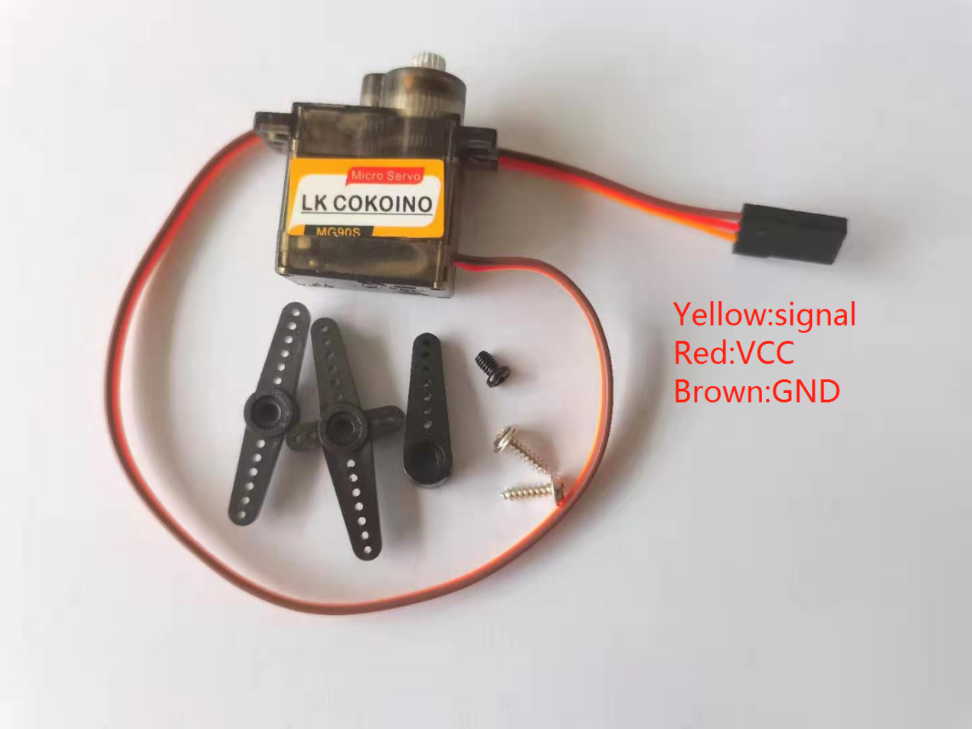

## **1.2 Pins**

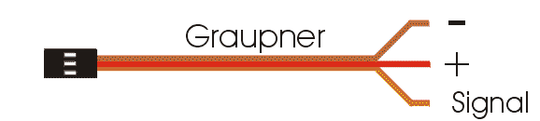

## **1.3Parameters**

1.3.1 Electrical parameters

|  |  |  |
| --- | --- | --- |
| No. | （Item） | 5V |
| 1.3.1.1 | No-load current | 120±20mA |
| 1.3.1.2 | load current | 160±20mA |
| 1.3.1.3 | No-load speed | 0.11sec/60º |
| 1.3.1.4 | Quiescent Current | 10mA |
| 1.3.1.5 | No-load life | 50000 times |
| 1.3.1.6 | stall torque | 1.5Kg.-cm |
| 1.3.1.7 | Stall current | ≦1A |
| 1.3.1.8 | Temperature drift (ambient temperature 25º) | ≦1º |
| 1.3.1.9 | temperature resistance | -20°C |

1.3.2 Structural parameters

|  |  |  |
| --- | --- | --- |
| No. | （Item） | Specification |
| 1.3.2.1 | Physical dimension | 32.6*12.1*22.5mm |
| 1.3.2.2 | Weight | 12G |
| 1.3.2.3 | Mechanical limit angle | 360º |
| 1.3.2.4 | Gear type | Grade 5 Metal Gear Set |
| 1.3.2.5 | Output tooth spline | 20T |
| 1.3.2.6 | Wire length | 250±5mm |
| 1.3.2.7 | Gear virtual position | ≦2º |
| 1.3.2.8 | Wire | 50C/0.08 　OD1.0 JR Connector |
| 1.3.2.9 | Swing arm | One Word Rocker Cross rocker Flower rocker |
| 1.3.2.10 | Motor | DC motor |
| 1.3.2.11 | Shell material | PC |

1.3.3 Control parameter

|  |  |  |
| --- | --- | --- |
| No. | （Item） | Specification |
| 1.3.3.1 | Control signal | PWM cycle 50HZ |
| 1.3.3.2 | Pulse width range | 1000us-2000us |
| 1.3.3.3 | Amplifier type | Number |
| 1.3.3.4 | Rotation angle | 90°±3°(when 1000～2000usec) |
| 1.3.3.5 | Midpoint | 1500usec |
| 1.3.3.6 | Dead zone width | ≦5usec |
| 1.3.3.7 | Direction of  rotation | Clockwise(when 1000～2000usec) |
| 1.3.3.8 | Return error | ≦1º |
| 1.3.3.9 | Over-operating angle range | 180º(500-2500usec) |
| 1.3.3.10 | Angle error on both sides | ≦5º |

## 

## **1.4 Working Principle**

The control signal of the servo is a PWM signal with a period of 20ms, in which the pulse width is from 0.5ms-2.5ms, and the corresponding position of the servo is 0-180 degrees, which changes linearly.Provide it with a certain pulse width, and its output shaft will remain at a corresponding angle, no matter how the external torque changes, until a new pulse signal of different width is provided to it, it will change the output angle to the new corresponding position. There is a reference voltage inside the servo, which generates a reference signal with a period of 20ms and a width of 1.5ms. There is a comparator that compares the applied signal with the reference signal to determine the direction and size, thereby generating the rotation signal of the motor. The internal control circuit board of the servo receives the control signal from the signal line, and controls the rotation of the motor. The motor drives a series of gear sets, which are driven to the output steering wheel after deceleration. The output shaft of the servo is connected to the position feedback potentiometer. When the steering wheel rotates, it drives the position feedback potentiometer. The potentiometer will output a voltage signal to the control circuit board for position feedback. The control circuit board determines the rotation direction and speed of the motor according to the position of the output shaft, so that the output shaft stops when it reaches the target.

## **1.5 PWM Control**

1.5.1 PWM Introduction

Pulse width modulation (PWM) refers to the use of the digital output of a microprocessor to control an analog circuit, and is a method of digitally encoding the level of an analog signal.

PWM (Pulse Width Modulation): Pulse Width Modulation

Pulse: square wave, frequency (freq)

Width: the width of the high level, the duty cycle (duty)

Cycle: CYCLE

Duty cycle: the proportion of high level (100&%)

Duty cycle static diagram:

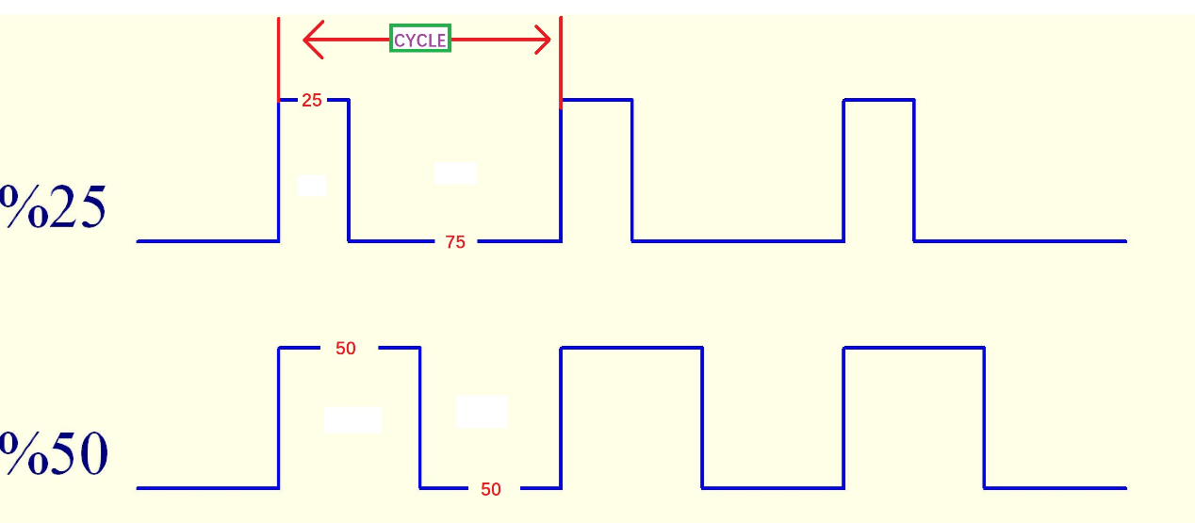

The relationship between the output angle of MG90S Micro Servo and the pulse width of the input signal

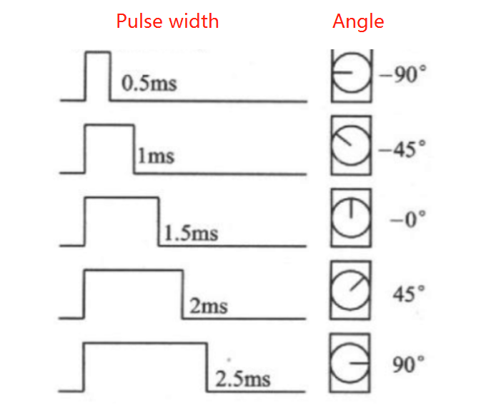

CYCLE=20ms

Duty_16=65532*Pulse Width/CYCLE

The relationship between the corresponding pulse width and duty_u16:

|  |  |
| --- | --- |
| Pulse Width(ms) | Duty_16 |
| 0.5 | 1638 |
| 1 | 3276 |
| 1.5 | 4914 |
| 2 | 6552 |
| 2.5 | 8192 |

# Component List

This lesson uses the Arduino UNO R3 board to test the MG90S Micro Servo. Please note that the kit does not include the Arduino UNO R3 board and requires personal preparation.

|  |  |  |  |
| --- | --- | --- | --- |
| Component | QTY | Picture | Remark |
| MG90S Micro Servo | 1 | mg90舵机 |  |
| UNO R3 Board | 1 | UNO | Prepared by yourself |
| Male to Male DuPont wire | 3 | 公对公杜邦线 | Prepared by yourself |

# Circuit connection

Connect the yellow signal pin of the MG90S Micro Servo to pin2 of the UNO board through a Male to Male DuPont wire, connect the red VCC pin of the MG90S Micro Servo to the 5V of the UNO board, and connect the brown GND pin of the MG90S Micro Servo to the GND of the UNO board.

**Circuit connection diagram:**

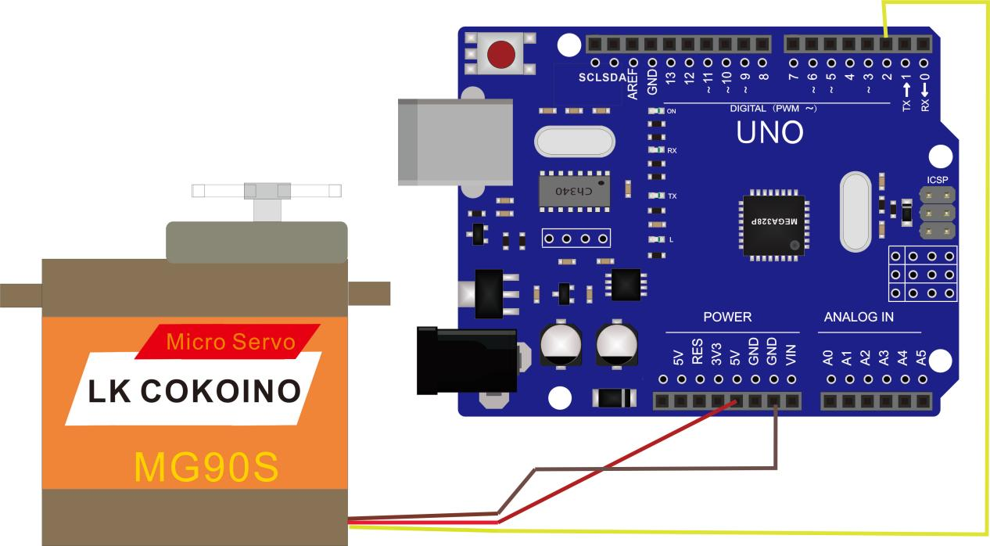

# Install the Servo library

Double-click the Arduino IDE shortcut on the desktop to open it

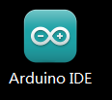

The code used in this lesson is placed in this folder：“ E:\CKK0020-main\Tutorial\sketches ”,Click "File" --- "open"

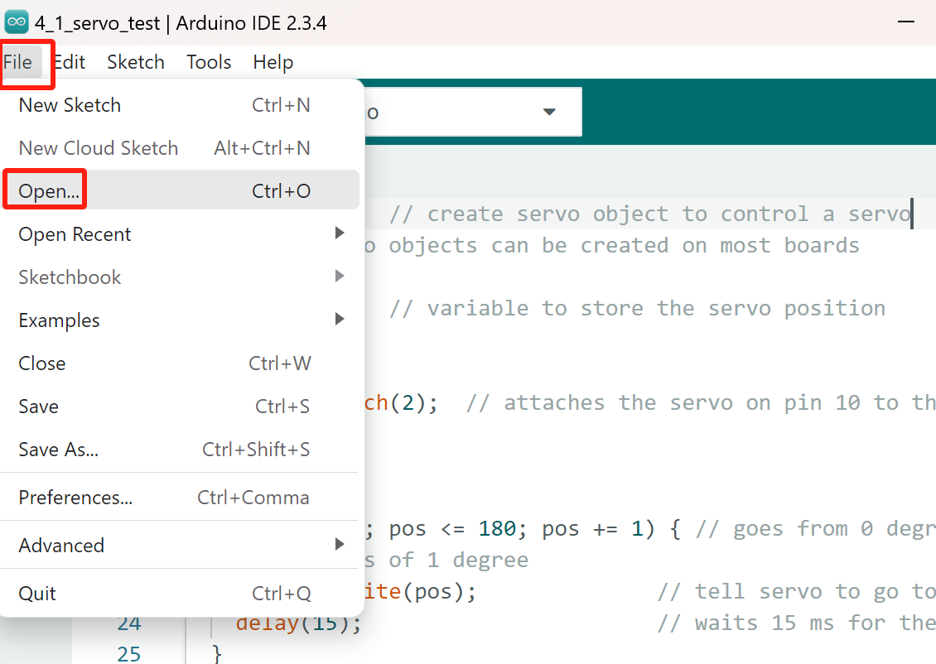

Select the code in the folder named 2_1_servo_test：

E:\CKK0020-main\Tutorial\Arduino\sketches\2_1_servo_test. Click "open"

Open the code interface as follows

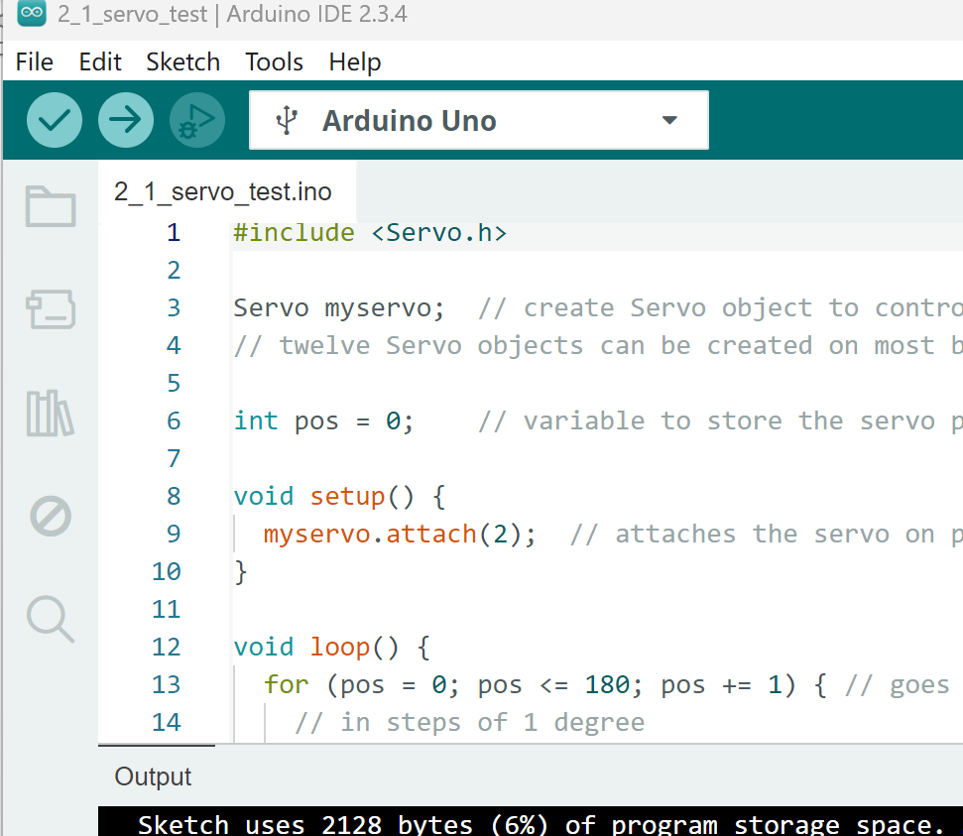

Method 1: Directly click "Library Manager" on the left side of the Arduino IDE interface, the interface is as follows

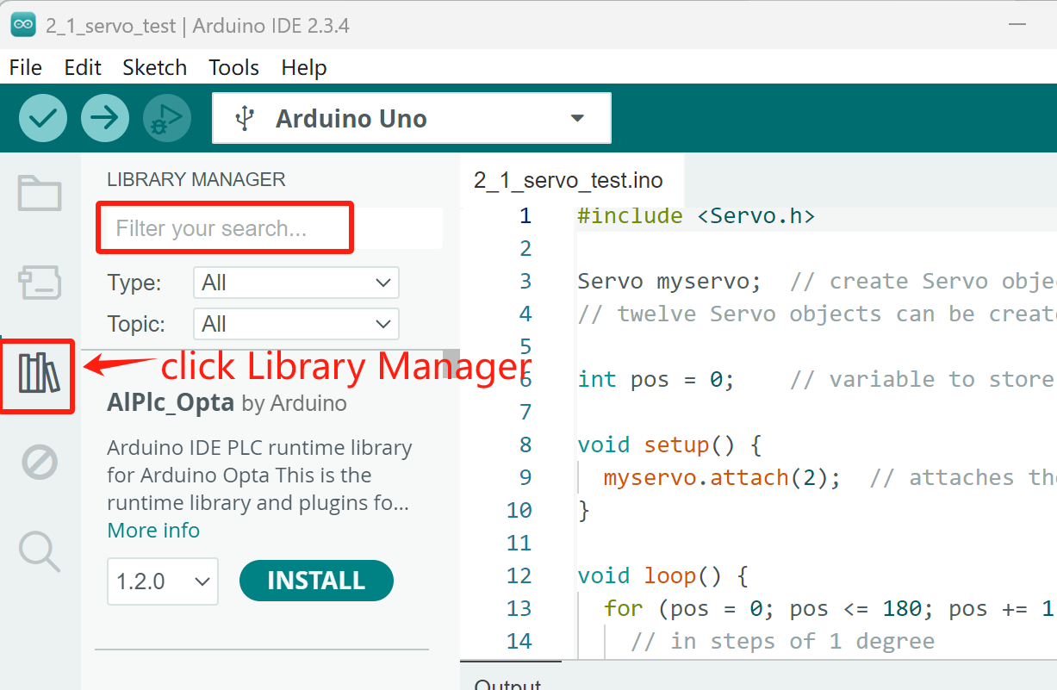

Search for Servo in the red search box, Library Manager will quickly match related library files.

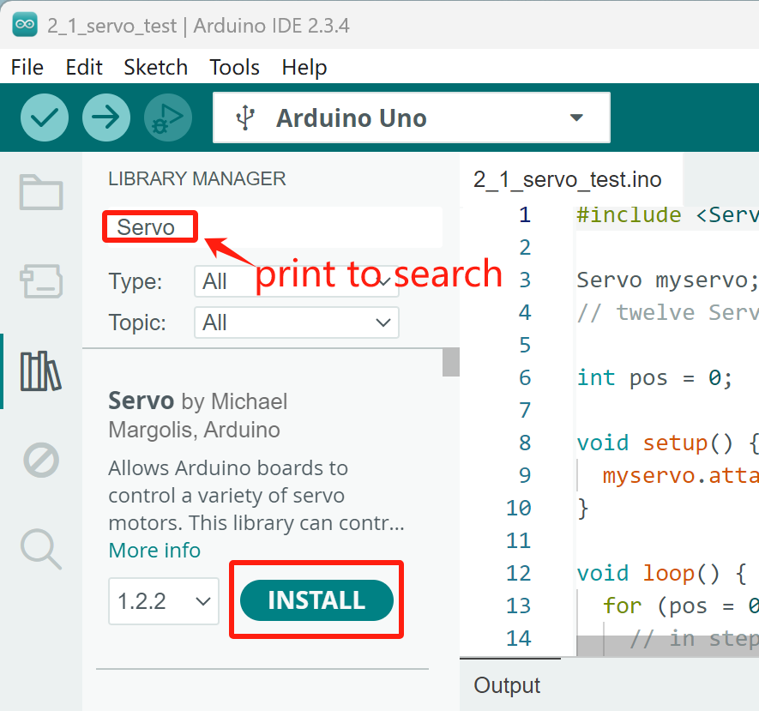

Click "INSTALL" to install the library file of Servo. After the installation is complete, it will display "installed"

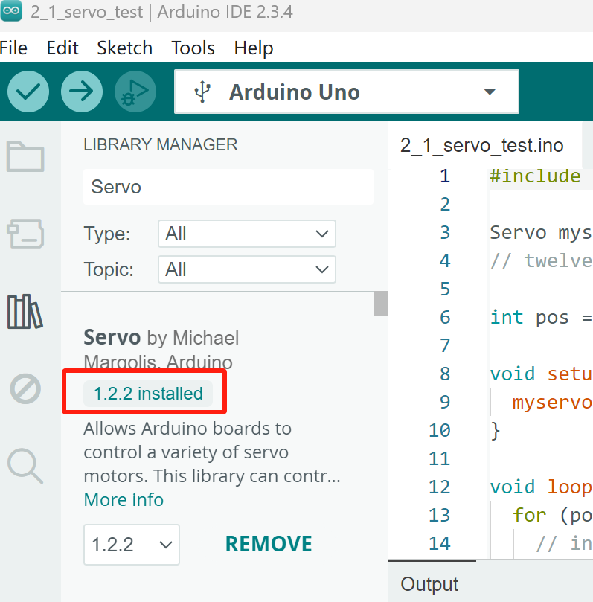

Method 2: In the Arduino IDE interface, click "Sketch" --- "Include Library" --- "Manage Libraries..." to open the library management interface.

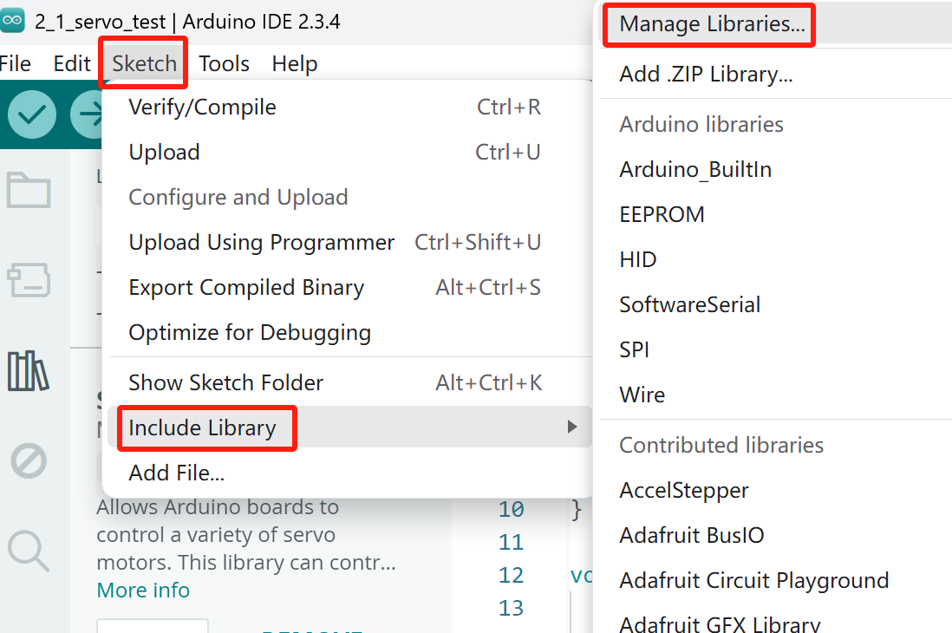

Search for Servo in the red search box, Library Manager will quickly match related library files.



Click "INSTALL" to install the library file of Servo. After the installation is complete, it will display "installed"



Method 3：In the Arduino IDE interface, click "Sketch" ---“Include Library”---“Add.ZIP Library…”

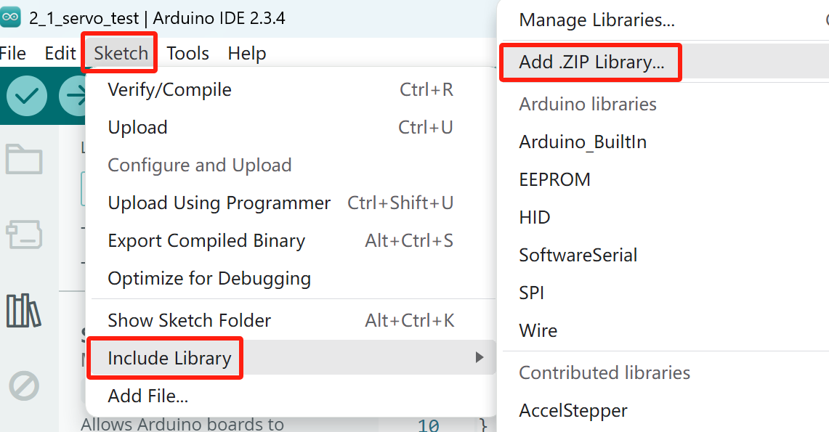

Find the Servo.ZIP file in E:CKK0020-main\Libraries\Servo.zip"

Double click the Servo.ZIP file,then it will be installed into Arduino IDE

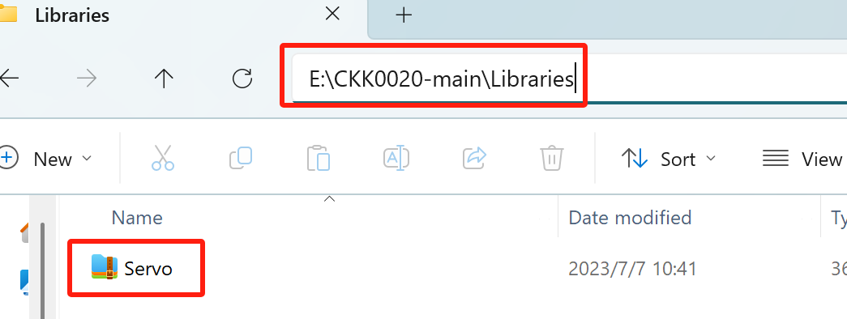

# Upload code and test the MG90S Micro Servo

5.1 Connect the Arduino UNO board to the computer through a USB cable, click the “Select Board” to select the Arduino Uno and Serial ports corresponding to the UNO board

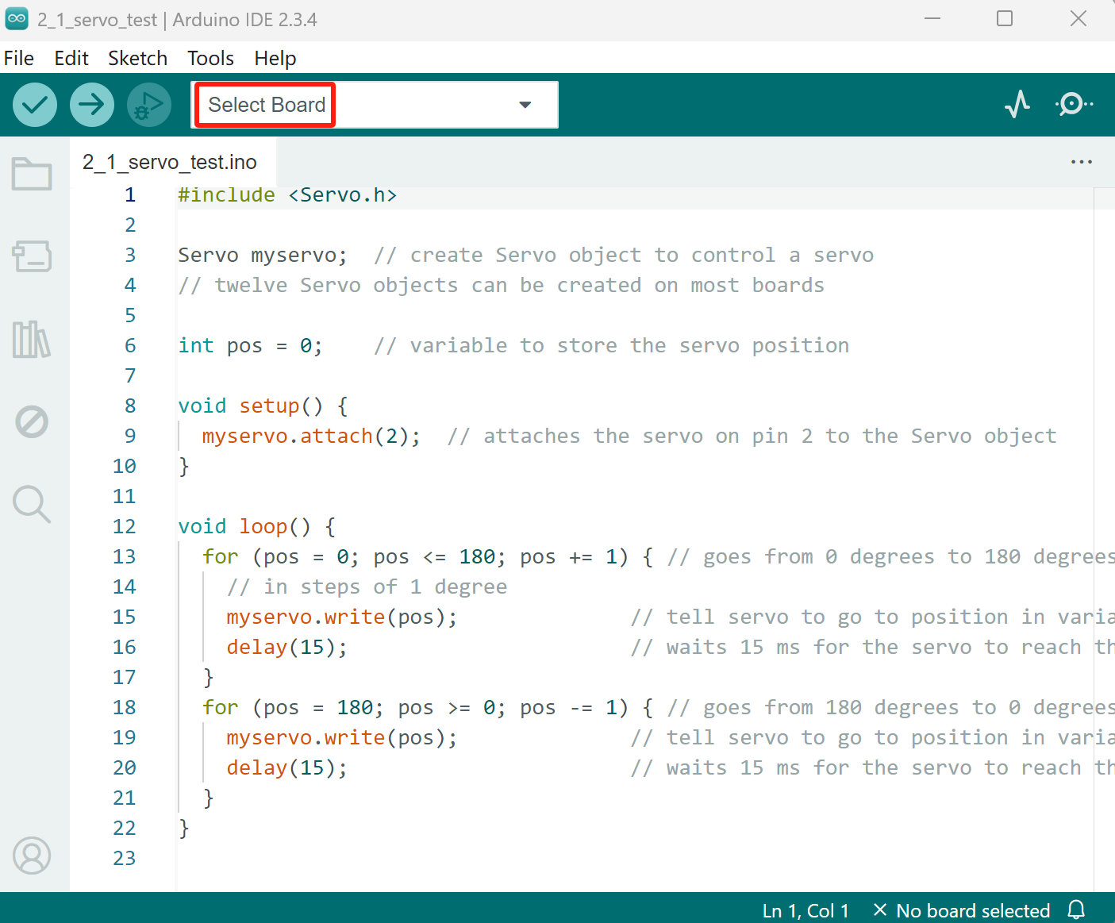

5.2 The UNO board COM port on my computer here is COM10, select “COM10”,then click “OK”.

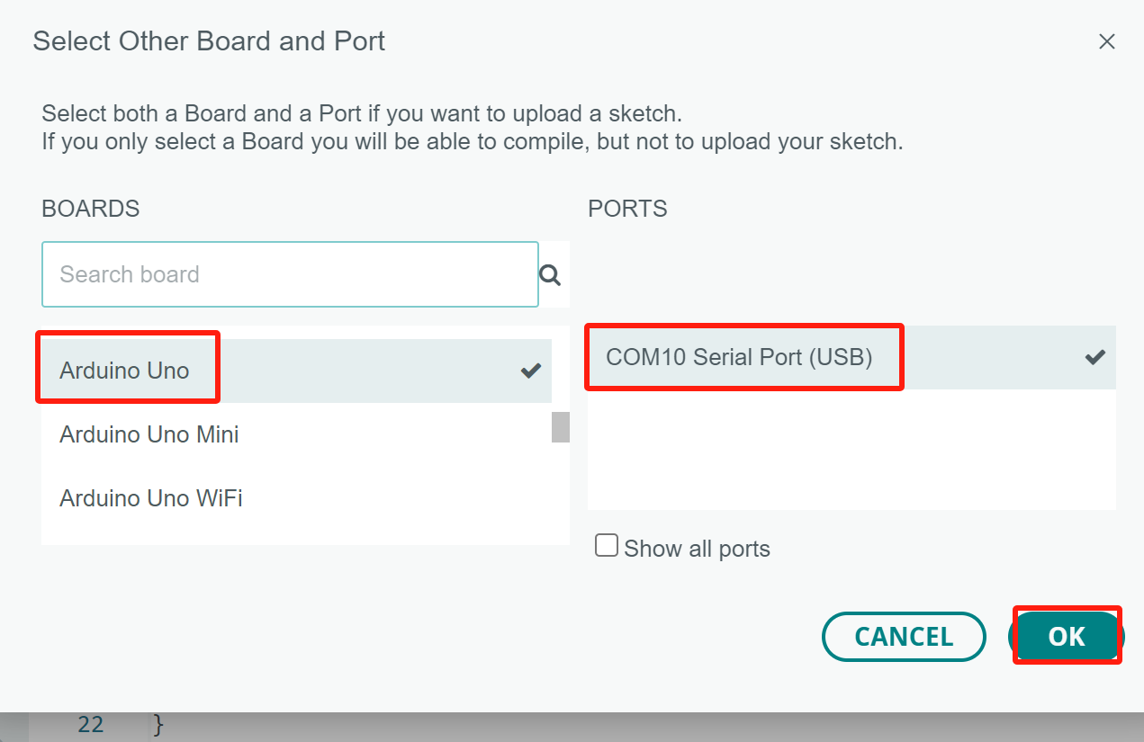

5.3 click the  button to compile the code,successfully compiled the code will display “Done compiling”

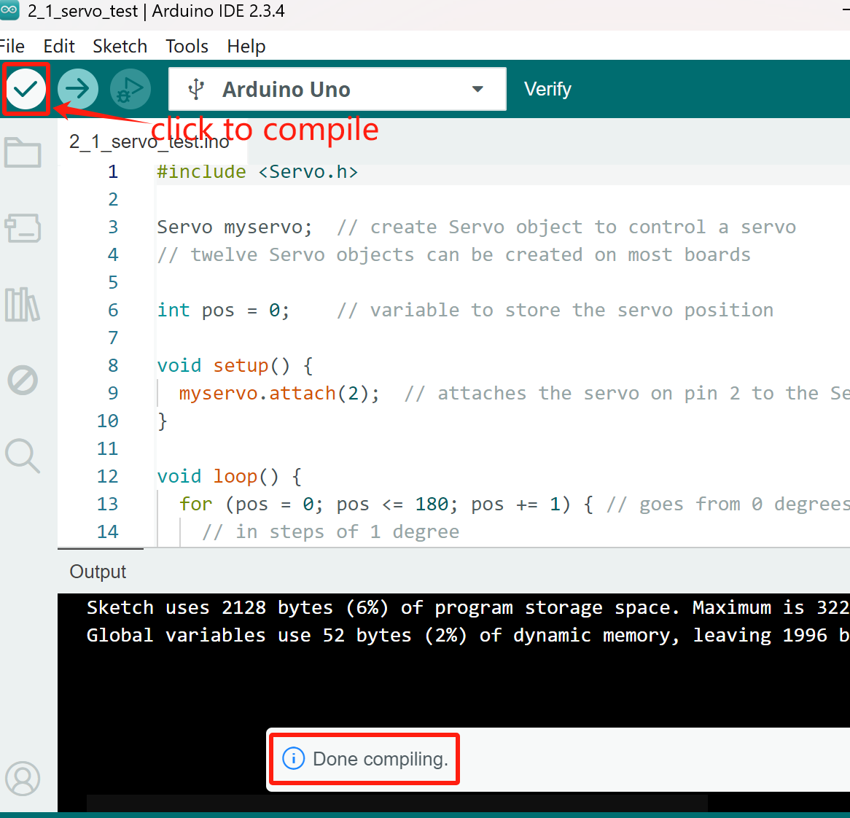

5.4 Click the "upload"  button on the IDE interface to start uploading the code to the UNO board.

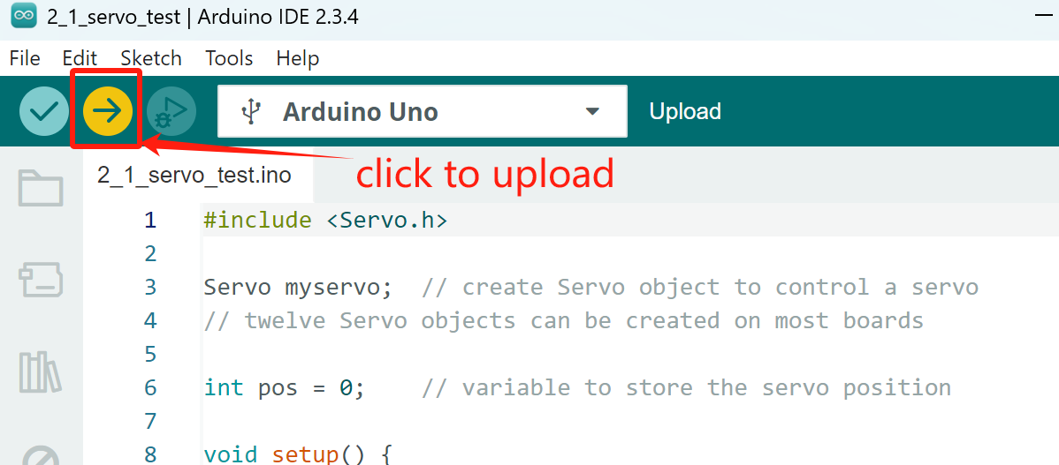

5.5 "Done uploading" will be displayed when the program upload is completed.

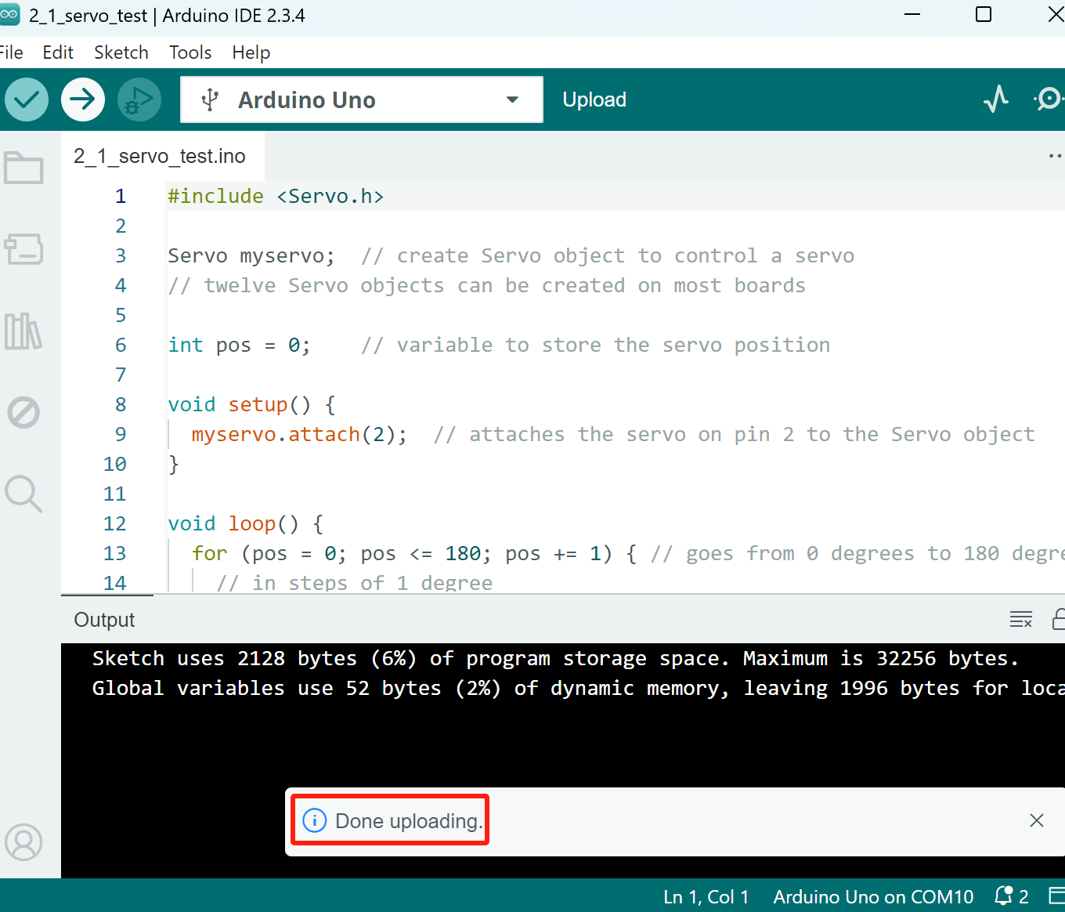

After the code is upload successed, you can see that the MG90S Micro Servo rotates 180 degrees in a loop.

# Adjust the MG90S Micro Servo to 90 degrees

If the MG90S Micro Servo test ok, We need to adjust it to 90 degrees before assembly. Because it is a 180 degree servo, adjusting it to a 90 degree position and installing it on the front wheel steering shaft of the chassis ensures that the maximum angle of rotation for the front wheels in both directions is the same.

6.1 Select the code in the folder named 2_2_servo_90_ADJ：

E:\CKK0020-main\Tutorial\Arduino\sketches\ 2_2_servo_90_ADJ.

Open the code interface as follows

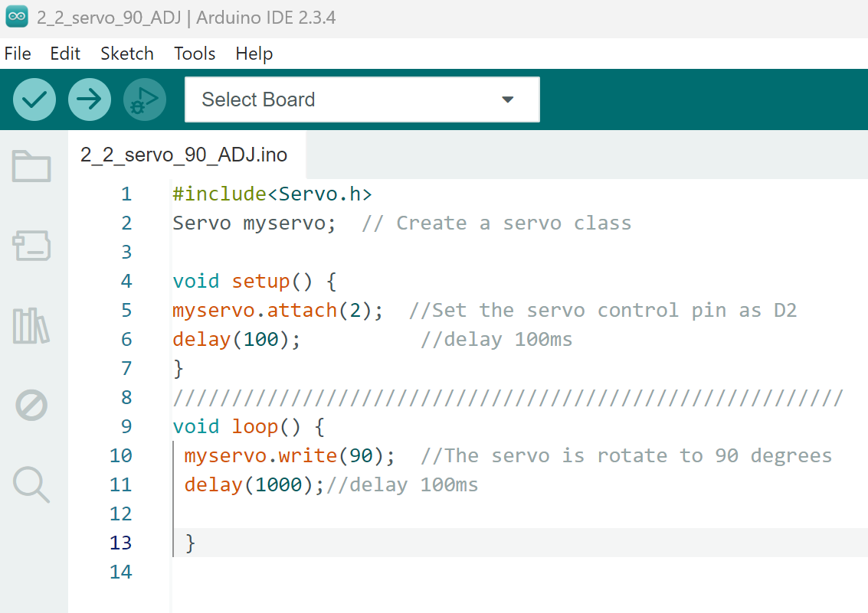

6.2 click the  button to compile the code,successfully compiled the code will display “Done compiling”.

6.3 Click the "upload"  button on the IDE interface to start uploading the code to the UNO board.

6.4 After the code is upload successed，the MG90S Micro Servo will rotates to 90 degress.

6.5 At this point, we unplug the USB cable and remove the servo. Ensure not to manually rotate the servo before assembly. If accidentally rotated, the servo needs to be reset to 90 degrees.

# Make your suggestion and get support

THANK YOU for participating in this learning experience!

If you find errors, omissions or you have suggestions and/or questions about this document, please feel free to contact us: **[cokoino@outlook.com](mailto:cokoino@outlook.com)**

We will make every effort to make changes and correct errors as soon as feasibly possible and publish a revised version.

If you want to learn more about Arduino, Raspberry Pi, Smart Cars, Robotics and other interesting products in science and technology, please continue to visit our Amazon Store by search for "LK COKOINO" on Amazon. Or visit our official website: [www.cokoino.com](http://www.cokoino.com)

We will continue to launch fun, cost-effective, innovative and exciting products.

Thank you again for choosing Cokoino products.

**LK COKOINO**